PHYSICIAN INFORMATION PACKET • 2026
Established in 2014 • Fully operational Downtown Vancouver / Yaletown clinic
SINA HEALTH CENTRE
YALETOWN • 505 SMITHE STREET
Join an Established Practice. Focus on Patient Care.
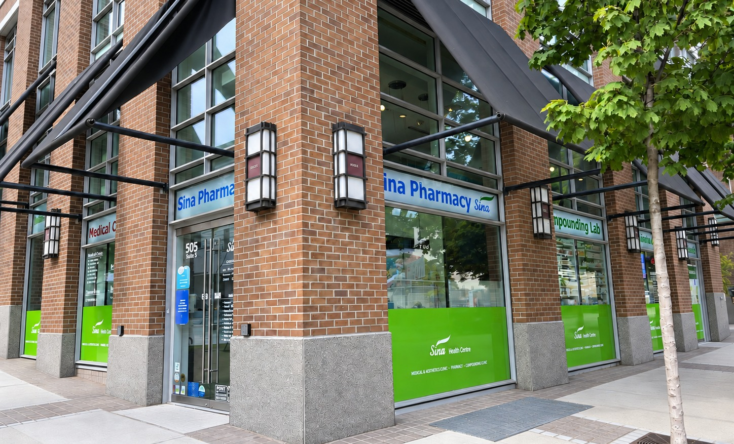
PERMANENT FAMILY PHYSICIAN / SPECIALIST PHYSICIAN • FULL-TIME OR PART-TIME
ESTABLISHED PATIENT POPULATION  Join a fully operational practice with established patient flow. | 6 FULL-TIME MOAs + CLINIC MANAGER  Experienced administrative and operational support already in place.
FULL-TIME RN + 3 CLINICAL PHARMACISTS  Integrated clinical support for patients and physicians. | 5 FAMILY PHYSICIANS + SPECIALISTS  An established multidisciplinary team with opportunities to collaborate.
6 EXAM ROOMS + 2 RECEPTION AREAS  Patient-ready infrastructure for efficient family and specialty care. | IN-HOUSE PHARMACY & COMPOUNDING  On-site pharmacy and compounding support within the same centre.

WHY SINA HEALTH CENTRE • YALETOWN
Ready From Day One.
An established practice environment with the staffing, patient base and clinical infrastructure already in place.
For physicians looking to establish, relocate or expand a practice in Vancouver, the Yaletown location offers the advantage of joining a fully operational medical centre rather than building a practice from the ground up.
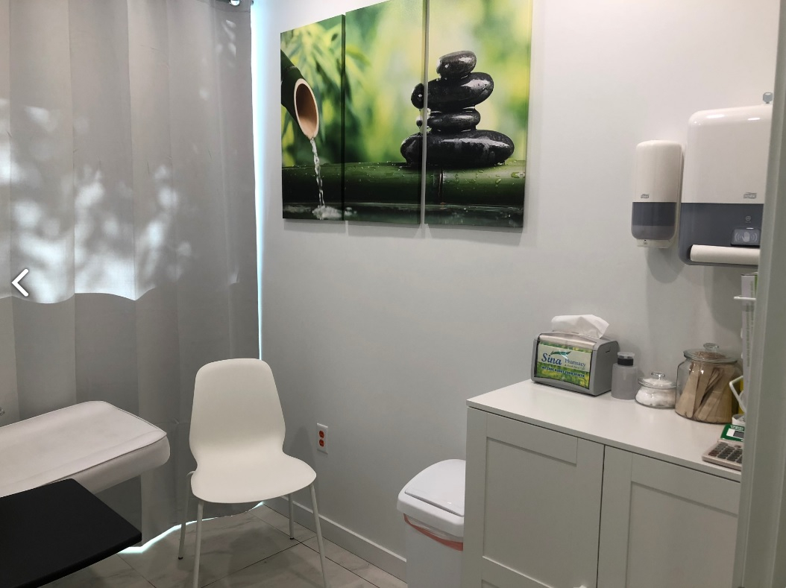
2014  Established | 6  Exam rooms | 6  Full-time MOAs | 3  Clinical pharmacists
ESTABLISHED PATIENT POPULATION  A mature Downtown Vancouver practice with existing demand and established clinical workflows. |  | EXPERIENCED OPERATIONS  Six full-time MOAs and a dedicated Clinic Manager support the day-to-day work around physicians.
FLEXIBLE PRACTICE  Permanent full-time or part-time opportunities, with schedules and practice requirements discussed individually. |  | COLLABORATION & REFERRALS  Family medicine, specialty care, nursing and pharmacy create opportunities for appropriate collaboration and internal referrals.

01 • CLINIC OVERVIEW
An Established Downtown Clinic. A Collaborative Team.
A patient-ready environment for physicians who value support, continuity and multidisciplinary care.
Since 2014, Sina Health Centre has provided comprehensive healthcare at 505 Smithe Street in Downtown Vancouver, adjacent to Yaletown. The centre combines family medicine, specialist services, nursing, clinical pharmacy and an in-house pharmacy/compounding service in one established location.
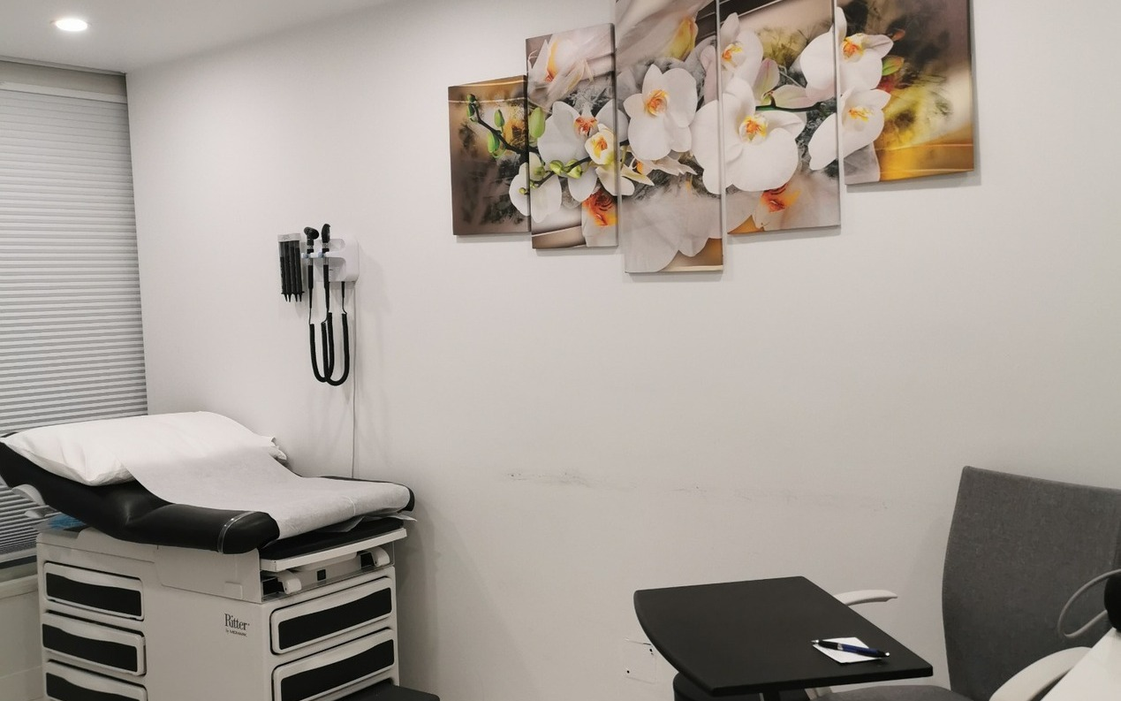
2014  Established | 6  Exam rooms | 2  Reception areas | In-house  Pharmacy
ESTABLISHED CLINICAL SPACE  Six exam rooms support efficient day-to-day family and specialty care. |  | MULTIDISCIPLINARY CARE  Family medicine, dermatology, pediatrics, nursing, clinical pharmacy and other specialties.
PATIENT FLOW SUPPORT  Two reception areas help coordinate check-in, scheduling and room utilization. |  | DOWNTOWN / YALETOWN PRESENCE  A central Vancouver clinic serving patients from Downtown, Yaletown and surrounding communities.

02 • SUPPORT & PRACTICE MODEL
More Time for Medicine. Less Time on Administration.
An experienced clinic team supports the operational work around physicians so clinical time can stay focused on patient care.
6 FULL-TIME MOAs  Scheduling, patient coordination, calls, faxes, referrals, investigations, recalls and front-desk workflow. | DEDICATED CLINIC MANAGER  Day-to-day operational oversight and an established administrative structure.
FULL-TIME NURSING SUPPORT  A registered nurse provides additional clinical support and helps coordinate patient care. | CLINICAL PHARMACY SUPPORT  Three clinical pharmacists support medication management, communication and continuity of care.
IN-HOUSE PHARMACY & COMPOUNDING  Convenient medication access, compounding services and pharmacist collaboration in the same location. | PROFESSIONAL AUTONOMY  Physicians maintain independent clinical judgment, referral choices and practice style.
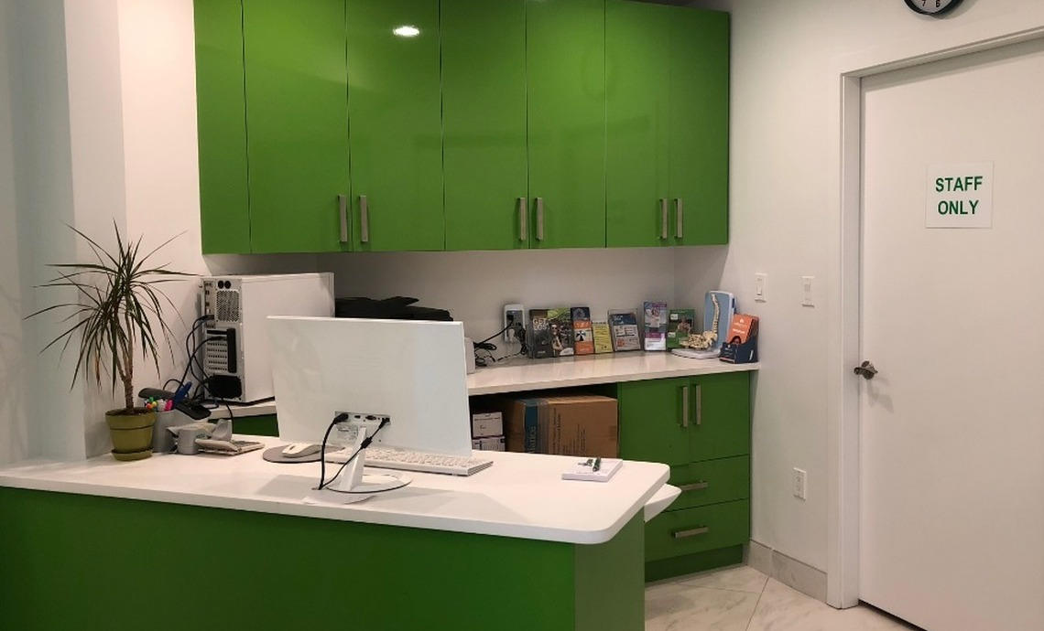
Our goal is a sustainable workday: physicians focus on patient care while the clinic team supports the operational work around it.

03 • CURRENT TEAM & INTEGRATED CARE
One Centre. An Established Clinical Community.
A multidisciplinary team creates opportunities for collaboration while preserving each physician’s professional independence.
PHYSICIAN TEAM  • 5 family physicians  • 1 locum physician providing vacation and overflow coverage  • 2 dermatologists  • 1 physician with a focused practice in dermatology  • 1 pediatrician | CLINICAL & ADMINISTRATIVE SUPPORT  • 1 full-time registered nurse  • 3 clinical pharmacists  • 6 full-time Medical Office Assistants  • Dedicated Clinic Manager  • On-site pharmacy and compounding pharmacy
The established family medicine presence and multidisciplinary environment provide opportunities for appropriate internal referrals and cross-referrals while physicians maintain independent clinical judgment and referral choices.


04 • LOCATION & COMMUNITY
A Practice in the Heart of Downtown Vancouver / Yaletown
505 Smithe Street is centrally located in Downtown Vancouver, adjacent to Yaletown, within a dense residential and commercial catchment.
The clinic serves patients who live and work throughout Downtown Vancouver, Yaletown and surrounding neighbourhoods. The location is convenient for patients, staff and physicians travelling by rapid transit, bus, bicycle or on foot.
WHY THE LOCATION WORKS  • Dense mix of residential towers, offices and established neighbourhoods  • Restaurants, cafés, retail, grocery and professional services within the downtown core  • Convenient access to Downtown Vancouver, Yaletown and False Creek  • Central location for community and referral-based practices | TRANSIT & DAILY ACCESS  • Canada Line access via Vancouver City Centre and Yaletown–Roundhouse stations  • Expo Line access via Granville Station  • Multiple downtown bus routes and walkable connections  • Canada Line connects Downtown Vancouver with Richmond and YVR Airport
NEARBY DESTINATIONS
Yaletown • Pacific Centre • Vancouver Public Library • Granville Street • Robson Street • BC Place • False Creek • Downtown core
CENTRAL VANCOUVER LOCATION • ESTABLISHED PATIENT CATCHMENT • EASY TRANSIT ACCESS

04 • LOCATION & COMMUNITY - continued
Connected to Downtown Vancouver
The clinic sits between major downtown destinations, residential towers, retail corridors and rapid-transit connections.
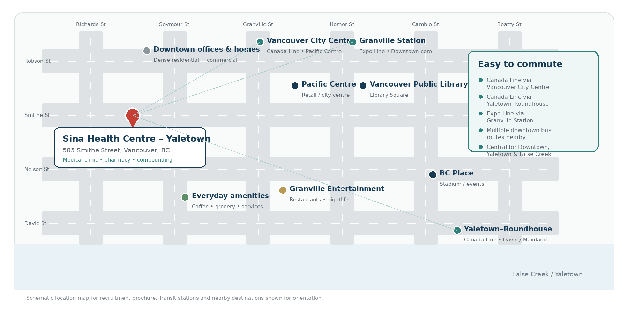
CANADA LINE ACCESS  Vancouver City Centre and Yaletown–Roundhouse stations provide Canada Line access through Downtown, Richmond and YVR. | DOWNTOWN TRANSIT  Granville Station and multiple bus corridors make the clinic accessible from across Vancouver and the Lower Mainland.
WALKABLE AMENITIES  Restaurants, cafés, retail, grocery, offices and residential towers are concentrated throughout the surrounding downtown area. | NEARBY LANDMARKS  Pacific Centre, Vancouver Public Library, BC Place, Granville Street, Yaletown and False Creek are nearby.

05 • THE FACILITY
The Centre, From Every Angle
Established, patient-ready spaces designed for efficient care and a professional clinical experience.
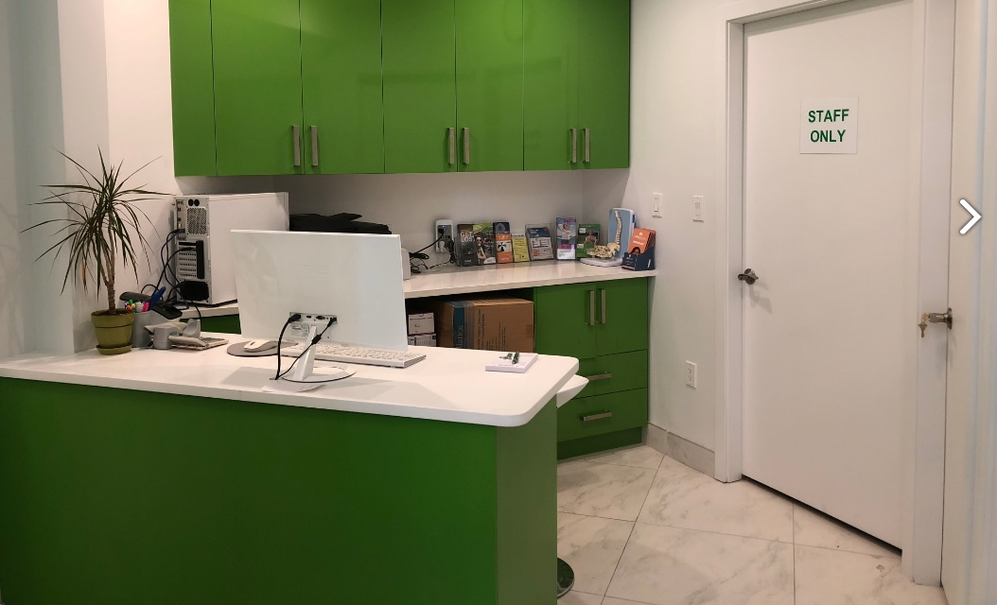  Reception & front desk | 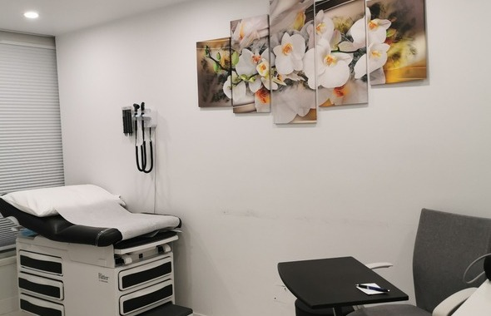  Clinical examination room
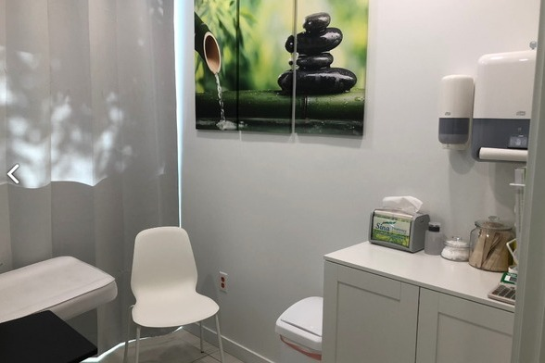  Patient consultation room | 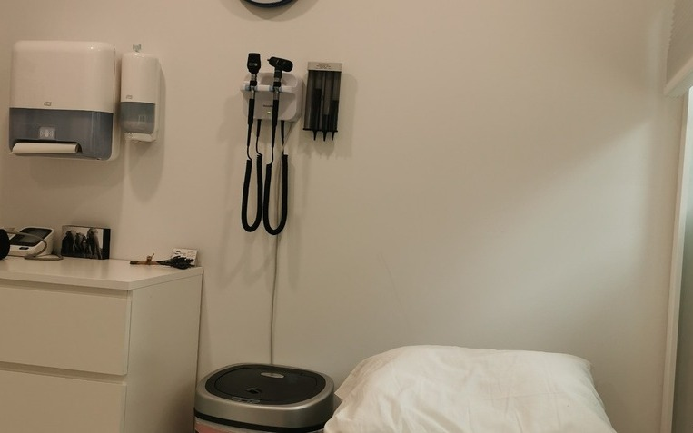  Clinical room & patient seating
IN-HOUSE PHARMACY & COMPOUNDING

06 • FAMILY & SPECIALIST OPPORTUNITIES
Build or Expand the Practice That Fits You
Permanent full-time and part-time opportunities for family physicians and specialist physicians.
FOR FAMILY PHYSICIANS  Establish or grow a longitudinal family practice within an existing patient community and mature clinic infrastructure.  • Suitable for physicians building a new patient panel  • Suitable for established physicians relocating or expanding  • Experienced MOA, nursing, pharmacy and management support  • Flexible full-time or part-time scheduling | FOR SPECIALIST PHYSICIANS  Establish or expand a referral-based practice within a centre that already includes family medicine, pediatrics, dermatology, nursing and clinical pharmacy.  • One or more clinic days per week or a larger practice  • Opportunities for appropriate internal referrals and collaboration  • Support for physicians building a Vancouver referral base  • Independent clinical judgment and referral choices
SPECIALTIES OF PARTICULAR INTEREST
Dermatology • Internal Medicine • Cardiology • Obstetrics & Gynecology • Endocrinology • Rheumatology • Psychiatry • Neurology • Other medical specialties
OPPORTUNITY DETAILS
JOB TITLE  Family Physician / Specialist Physician | JOB DETAILS  Permanent
SCHEDULE  Full-Time or Part-Time | START DATE  Immediately / By Mutual Agreement
LOCATION  505 Smithe Street, Vancouver, BC | PRACTICE SETTING  Family Practice / Specialist Practice / Multidisciplinary Medical Centre
CANDIDATE  Family physicians and specialists establishing, expanding, relocating or adding a Vancouver practice location. Applicants must be eligible for CPSBC licensure and MSP billing. | COMPENSATION  MSP-funded physician services. Practice and compensation arrangements are flexible and discussed based on specialty, schedule and individual practice requirements.
COME MEET THE TEAM • TOUR THE CLINIC • DISCUSS A PRACTICE MODEL THAT FITS YOU

07 • NEXT STEPS - CONTACT US
Come See the Clinic in Person
A clinic tour is the best way to understand the rooms, workflow, support and established practice environment.

ARRANGE A CONFIDENTIAL TOUR
1 • REACH OUT  Tell us about your goals, preferred schedule, specialty and practice needs. | 2 • TOUR THE CLINIC  See the exam rooms, reception areas, staff space, pharmacy and clinical workflow.
3 • MEET THE TEAM  Discuss administrative support, clinical resources, patient needs and collaboration opportunities. | 4 • PLAN YOUR START  Coordinate onboarding, schedule, practice transition and operational setup.
ARRANGE A CONFIDENTIAL TOUR
Sina Health Centre • 505 Smithe Street, Vancouver, BC • admin@mysina.ca

